Table 1
Chemcical properties of epoxy resin
Structural Situation | Two-component epoxy resin
Density | 1.23 gr/cm³
Appearance/color | Clear
Full cure | 7 day (23°C - %50 moisture)
Min. curing temperature | +8 °C
Adhesion strength | 2,5N/mm²
Application temperature | +8°C - +35°C
Water resistance | Very good
UV strength | High
Na₂O | 1,21
Loss of Glow | 3,34
Compressive strength | >30N/mm²
Heat resistance | -20 °C - +145 °C
First drying | 4 hours
Working time | 45-55 minute
Application temperature | 5 °C - 35 °C

Table 2
Measurement results of insulation board samples
Mechanical and physical properties | HS10 | HS20 | Average | P
Thermal Conductivity Coefficient (W/mK) | 0.136 | 0.148 | 0.142 | 0.008**
Ultrasonic Sound Transmission Rate (m/sn) | 1196 | 1270 | 1233 | 0.003**
Unit Volume Weight (g/cm³) | 1.543 | 1.592 | 1.567 | 0.003**
Water Absorption Rate (%) | 11.29 | 9.23 | 10.26 | 0.006**
Compressive Strength (MPa) | 1.13 | 1.47 | 1.3 | 0.014*

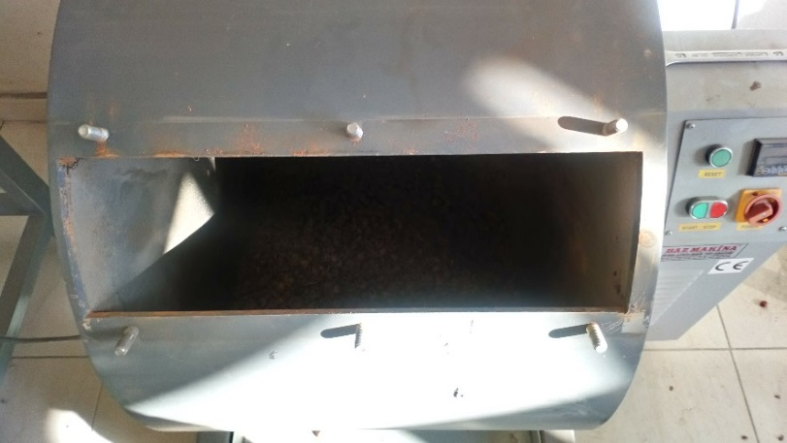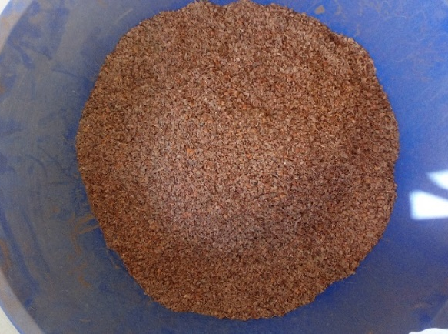
Fig. 1. Los Angles device and ground hazelnut shells
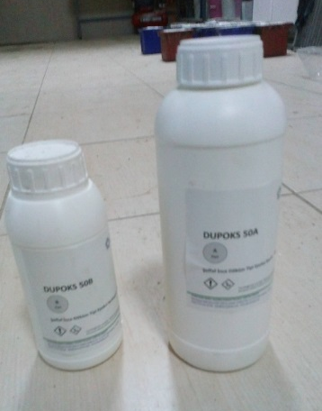
Fig. 2. Epoxy gel and binder

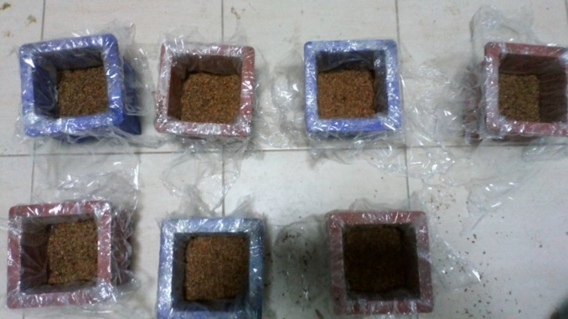
Fig. 3. Production of ınsulation board samples

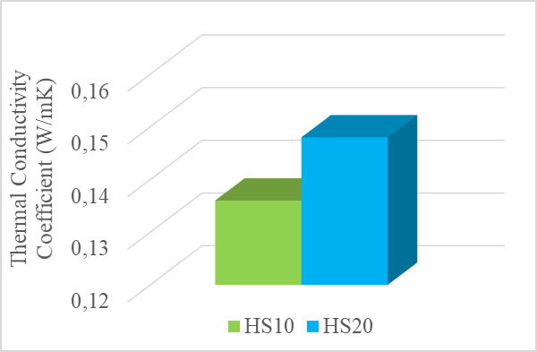
Fig. 4. Thermal conductivity coefficients of insulation board samples

Fig. 5. Sound transmission velocities of insulation board samples

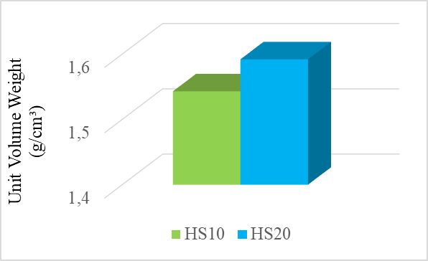
Fig. 6. Unit volume weights of insulation board samples

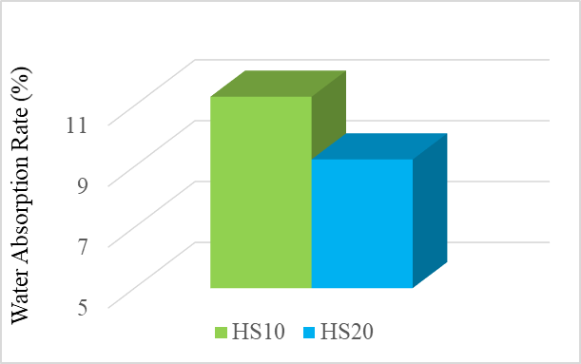
Fig. 7. Water absorption rates of insulation board samples

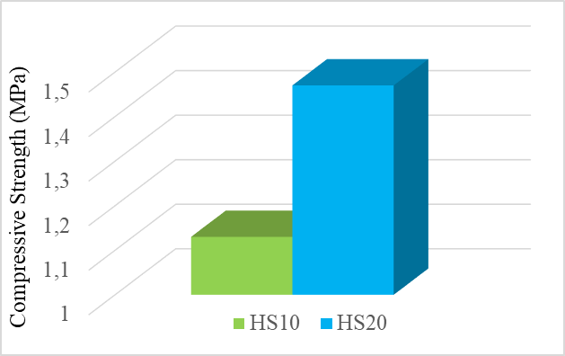
Fig. 8. Compressive strengths of insulation board samples

