SUPPLEMENTARY MATERIALS

Design of Experiment approach to optimize High Resolution ICP-OES method for biomonitoring of Zn level in human blood samples
Jan Sawicki, Magdalena Wójciak, Sławomir Dresler, Andrzej Torbicz, Agnieszka Skalska-Kamińska, Ireneusz Sowa
Department of Analytical Chemistry, Medical University of Lublin, 4A Chodźki St., 20-093 Lublin, Poland

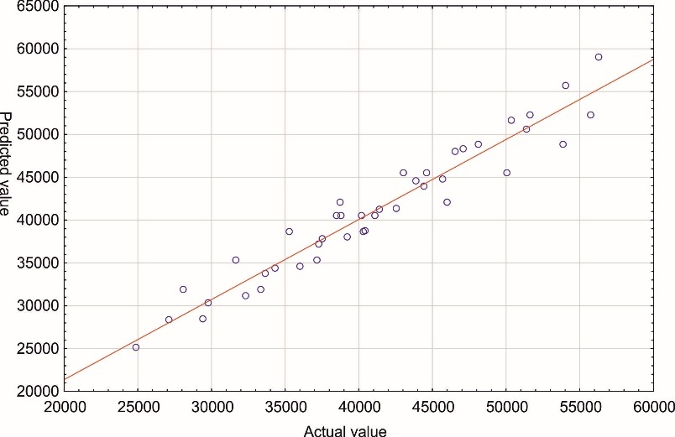
Fig. S1. Predicted vs. actual response

Fig. S2. Relationship between signal intensity and auxiliary gas flow - axial mode;
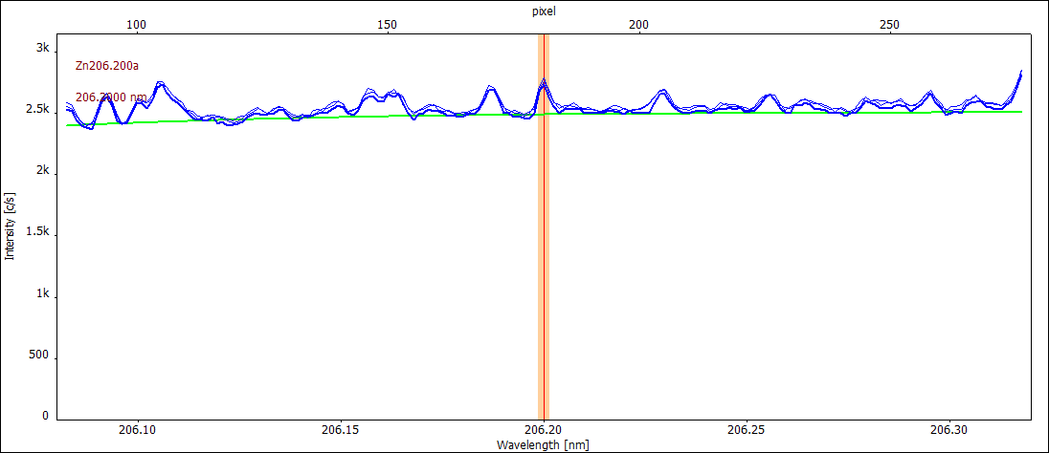
(a)
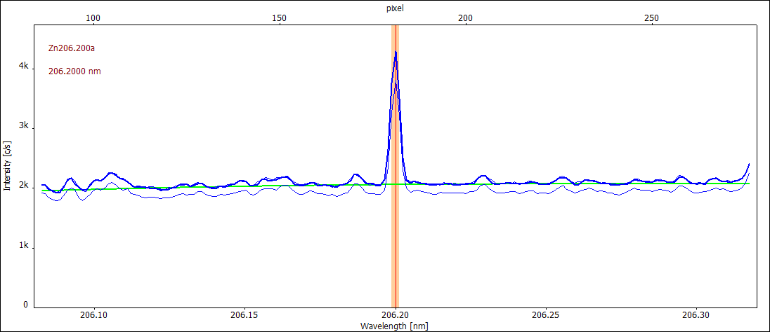
(b)
Fig. S3. Signal registered at wavelength 206.200 nm; (a) – blank oxidative mixture was heated in disposable vessel recommended for graphite block, (b) – blank oxidative mixture was heated using TOPwave system in reusable vessel previously subjected cleaning procedure recommended by manufacturer

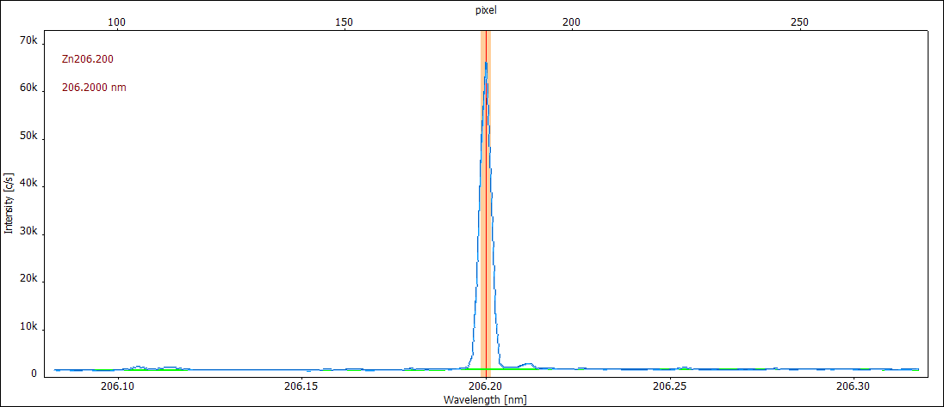
Fig. S4. Signal of Zn obtained in real blood samples after digestion
Table S1
Analysis of variance for quadratic model.
Source | Sum of Squares | Mean Square | F-value | p-value
Model | 2.523E+09 | 3.154E+08 | 59.19 | < 0.0001
RF Power (L) | 8.405E+08 | 8.405E+08 | 157.75 | < 0.0001
Plasma gas flow (L) | 2.220E+07 | 2.220E+07 | 4.17 | 0.0493
Nebulizer gas flow (L) | 1.156E+09 | 1.156E+09 | 217.03 | < 0.0001
Sample flow rate (L) | 3.879E+08 | 3.879E+08 | 72.80 | < 0.0001
RF Power (Q) | 1.084E+06 | 1.084E+06 | 0.2034 | 0.6549
Plasma gas flow (Q) | 4.093E+07 | 4.093E+07 | 7.68 | 0.0091
Nebulizer gas flow (Q) | 27343.19 | 27343.19 | 0.0051 | 0.9433
Sample flow rate (Q) | 8.092E+07 | 8.092E+07 | 15.19 | 0.0005
Residual | 1.758E+08 | 5.328E+06 | - | -
Lack of Fit | 1.714E+08 | 5.713E+06 | 3.87 | 0.1452
Pure Error | 4.427E+06 | 1.476E+06 | - | -
Cor Total | 2.699E+09 | - | - | -

Table S2
LOQ verification (n = 5)
no matrix
Zn concentration  [μg L⁻¹] | Concentration found  [μg L⁻¹] | u_{imp}  [%] | u_{bias}  [%] | U*  [%]
0.50 | 0.32 | 15 | -36 | 39
1.0 | 0.77 | 1.2 | -23 | 23
2.0 | 1.9 | 1.6 | -5.0 | 5.2
3.0 | 2.6 | 1.7 | -6.7 | 6.9
4.0 | 4.0 | 1.5 | 0.0 | 1.5
5.0 | 4.9 | 0.91 | -2.0 | 2.2
matrix matched
Zn concentration  [μg L⁻¹] | Concentration found  [μg L⁻¹] | u_{imp}  [%] | u_{bias}  [%] | U  [%]
0.50 | 0.34 | 13 | -32 | 34
1.0 | 0.78 | 4.4 | -22 | 22
2.0 | 1.9 | 3.7 | -5.0 | 6.2
3.0 | 2.8 | 3.6 | -6.7 | 7.6
4.0 | 3.9 | 1.6 | -2.5 | 3.0
5.0 | 4.8 | 2.1 | -4.0 | 4.5

*Combined standard uncertainty (U) was calculated from the formula:
$$\text{U}\text{= }\sqrt{{{\text{u}}_{\text{bias}}}^{\text{2}}\text{ + }{{\text{u}}_{\text{imp}}}^{\text{2}}}$$
u_{imp} – precision expressed as residual standard deviation of measurements [%],
u_{bias} - relative error [%]
Table S3
Regression analysis performed using GraphPad Prism 8.0 software.
Parameter | Matrix matched* | No martix
Equation | y = 394.6x + 2032 | y = 418.3x-145.0
R square | 0.99994 | 0.99995
95% Confidence Intervals slope | 385.5 – 403.6 | 409.3 – 427.3
95% Confidence Intervals  Y-intercept | -3042 - 7107 | -5184 - 4894
95% Confidence Intervals  X-intercept | -18,31 - 7,587 | -11,88 - 12,21
Residual sum of squares | 1655 | 1643
* matrix matched solution contains K 30 mg L⁻¹, Na 640 mg L⁻¹, Ca 20 mg L⁻¹, Mg 4 mg L⁻¹, Fe 100 mg L⁻¹

